Project Description
Physicist Biography/Tape Art
Mr. Vetter-HTHNC-Physics
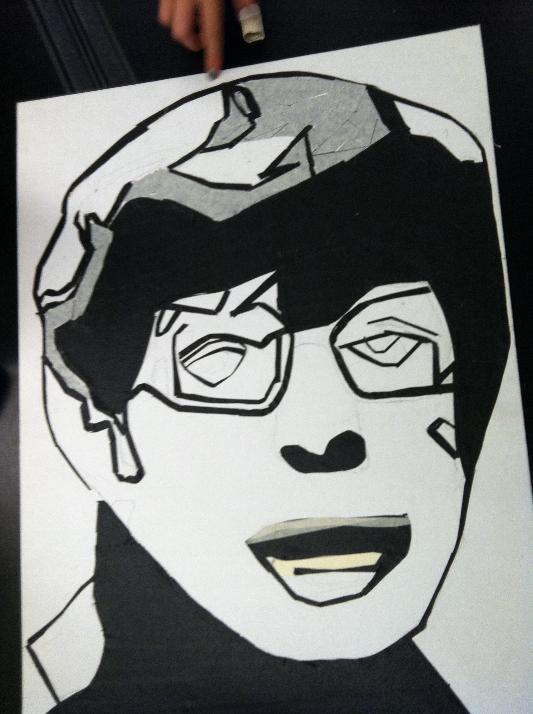

OVERVIEW: Students will be able to choose a physicist and prepare a biographical sketch that will focus on the scientific contributions as well as on the personal aspects of their lives. Students will also create portraits of their chosen physicists using masking tape as a medium.

ESSENTIAL QUESTION: What do we really know about these heroes of physics?

STUDENT OBJECTIVES:
- Understand the scientific contributions of their physicist.
- Research the personal life of their physicist.
- Create a beautiful portrait of their physicist using tape-art.
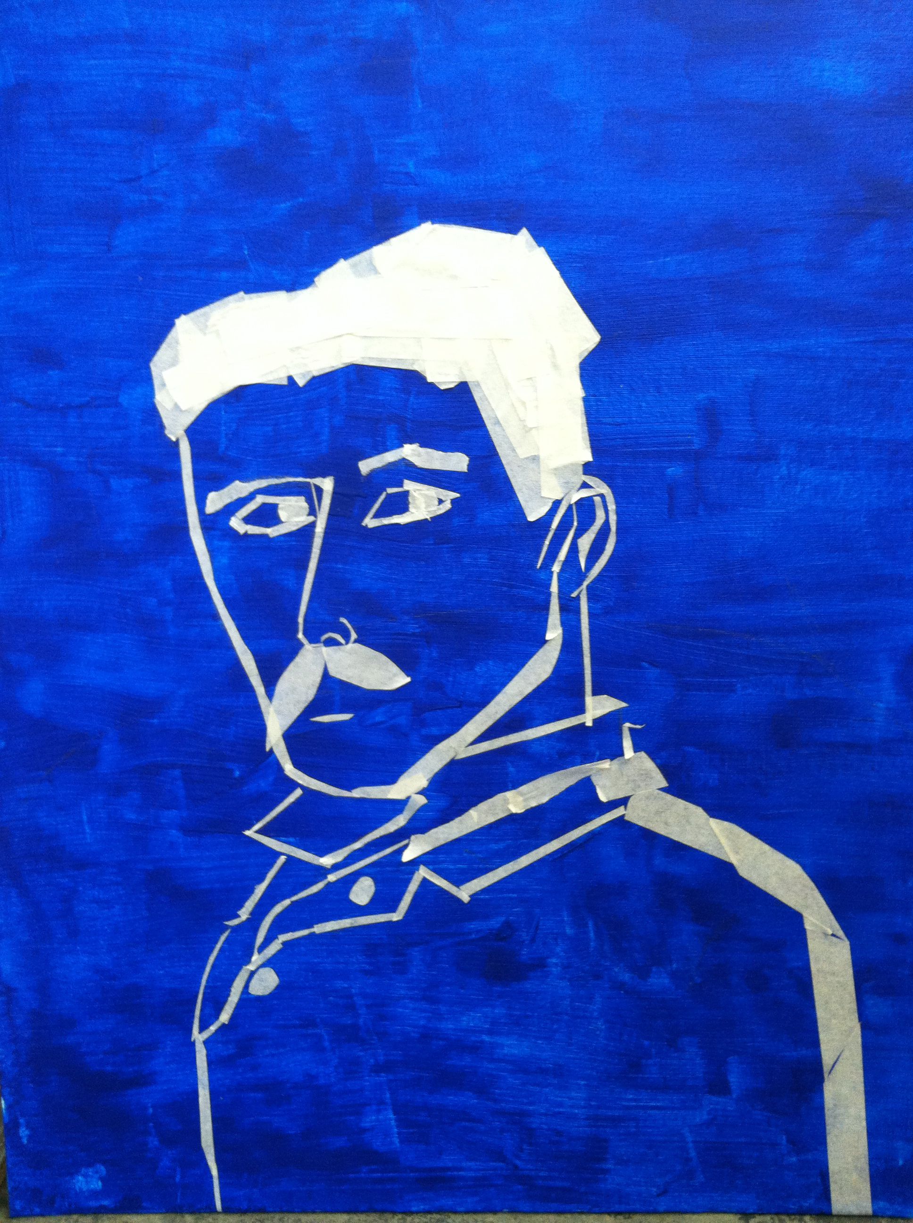
- Present their findings to the class in a short presentation.

BENCHMARKS:
- Choose a physicist. Every student in our class must choose a different physicist. Then print out a photo of your physicist. Due 10-20-14.
- Initial sketch of your physicist (pencil or pen on paper) Due 10-22-14.
- Choose background artwork for your portrait. This may include formulas, quotes, diagrams, and/or doodles that relay information about your physicist. (These images can be transferred to your portrait using a 'tracing paper technique.' We will practice this in class and I will post a video of this technique on my DP.) Due 10-24-14
- First draft of your portrait. (See diagram for instruction on the size and guidelines for your portrait) 10-27-14
- First draft of your biographical essay. Write a two page (400-500 word) essay. The first half should focus on the scientific accomplishments of your physicist. The second half should focus on the more personal aspects of their storied lives. 10-29-14
- Final Draft of your tape art portrait, including appropriate background art, that follows the guidelines provided. 11-4-14
- Final draft of your biographical essay. Typed in 12 point Times New Roman and double spaced please. 11-4-14
- Presentations. Five to seven minutes in duration. You will enlighten your classmates about your physicist. 11-4-14 and 11-5-14.
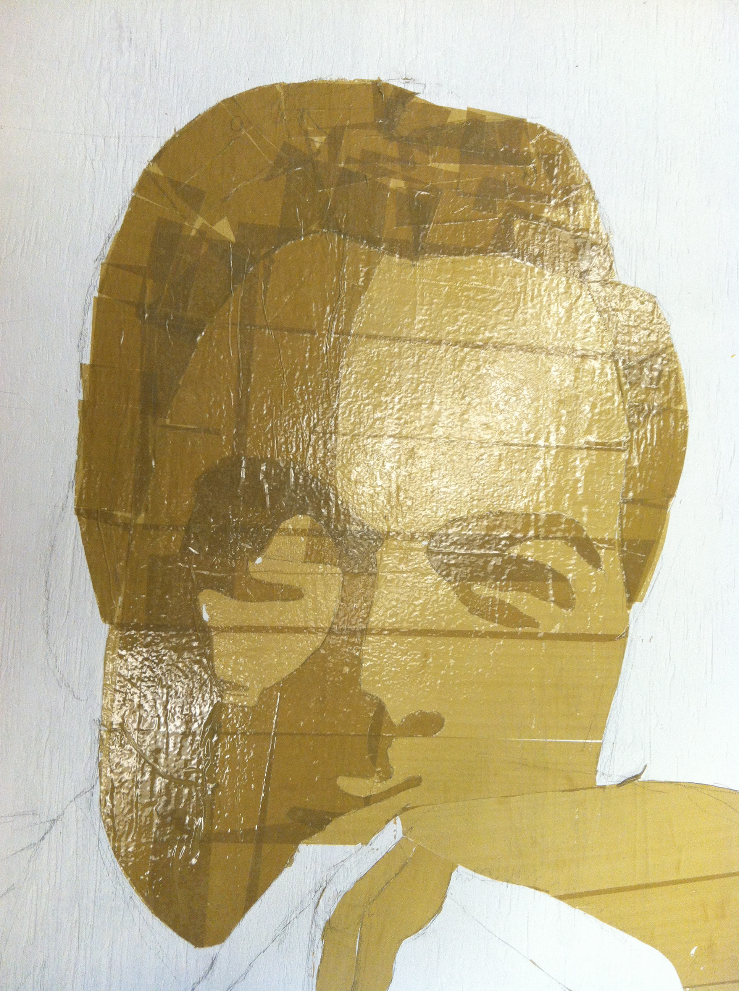

DIMENSIONS: Each portrait will be assembled from four 8.5”x11” sheets of cardstock paper (I have a wide variety of color options to choose from). Therefore, the height of the portrait will be 22” and the width will be 17”. Find below a rough draft of work in progress.

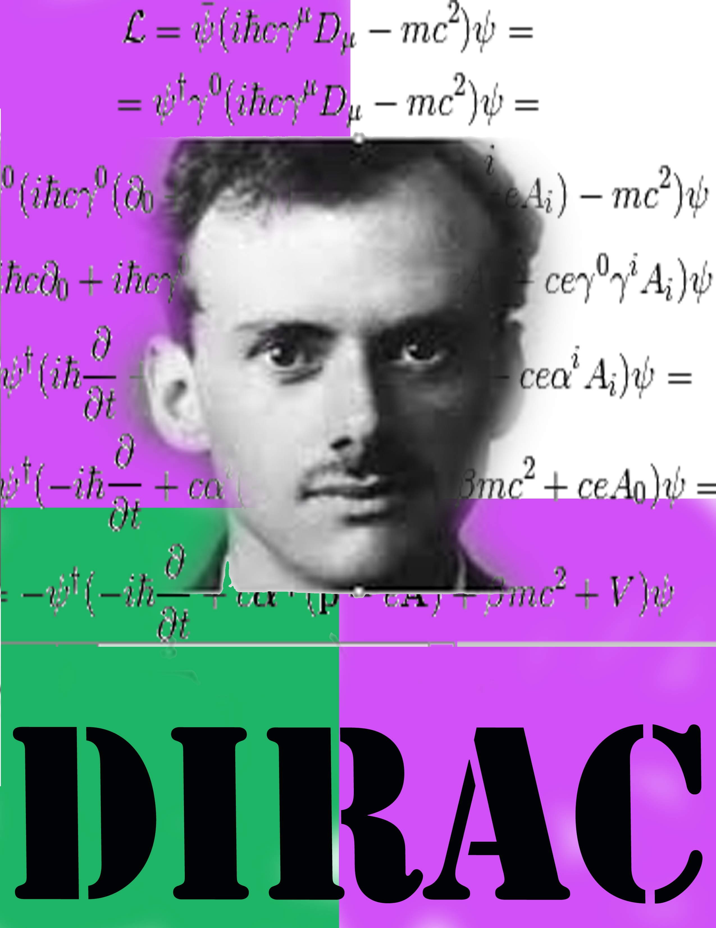

I will also provide stencils for the surnames of our physicists. If our portraits all have the same size letters and the same font then it will give our overall body of work a certain cohesion. This will tie the work together nicely when it is collectively exhibited.

